Line 1

Line 2











**Figure** **3** Four-node network

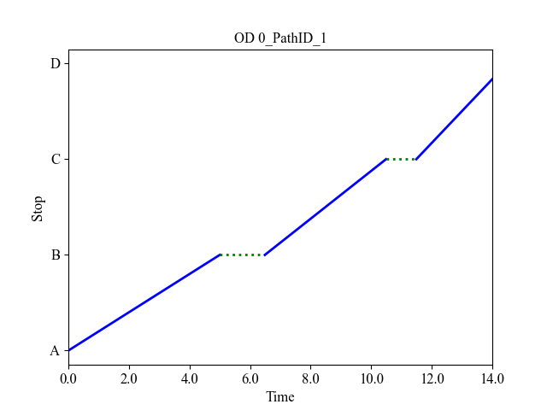

1. Trajectories of bus line 1
2. Trajectory of path (A 🡪 Line 1🡪 B 🡪 Line 2 🡪 D) between OD pair AD







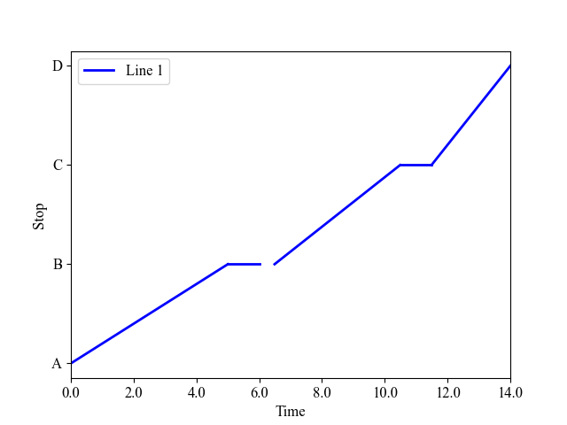

1 min

(minimum dwell time)

1 min

(minimum dwell time)

0.49 min

(additional time due to boarding/alighting)

**Figure** **4** Results of the four-node network